INTRUDER DETECTION CALLING SYSTEM

Int

Intruder Detection Calling System

DLC Project Report

Julakanti Harshitha

jn

**INTRODUCTION:**

I have made a simple device called "Intruder Detection Calling

System" using arduino. This device sends a call on the telephone

number feeded in the code, whenever it senses any movement. It is a

portable device which can be easily installed on the main gate of the

house. It is useful when the residents have gone out and the house is

empty. In such a scenario, if somebody tries to break in, our device

can sense movement and alert the owner by sending a call on his

mobile phone.

**COMPONENTS USED:**

• Arduino UNO

• PIR sensor

• SIM900 GSM/GPRS MODEM W/RS232

• A SIM card

• Some male to female wires

• A 9 Volt battery

• 9V battery cap with DC barrel

1



**CIRCUIT DIAGRAM:**

2

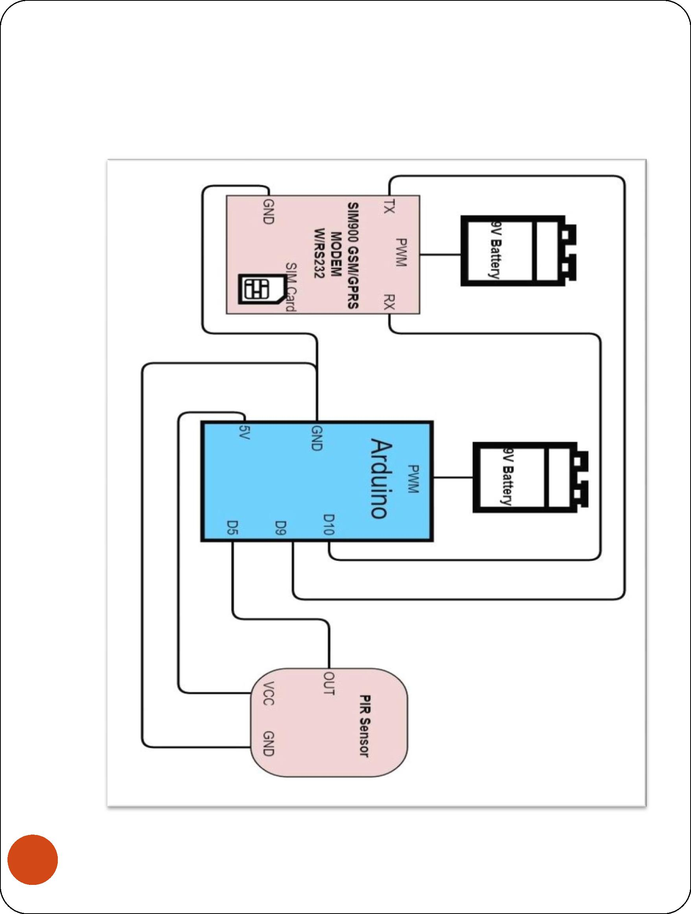

**WORKING:**

1) The PIR sensor in the device detects the motion and sends

the analog signal in form of volts to the Arduino

2) Arduino UNO when receives the signal activates the GSM SIM

900 Module and makes it to call the number feeded in the code

3

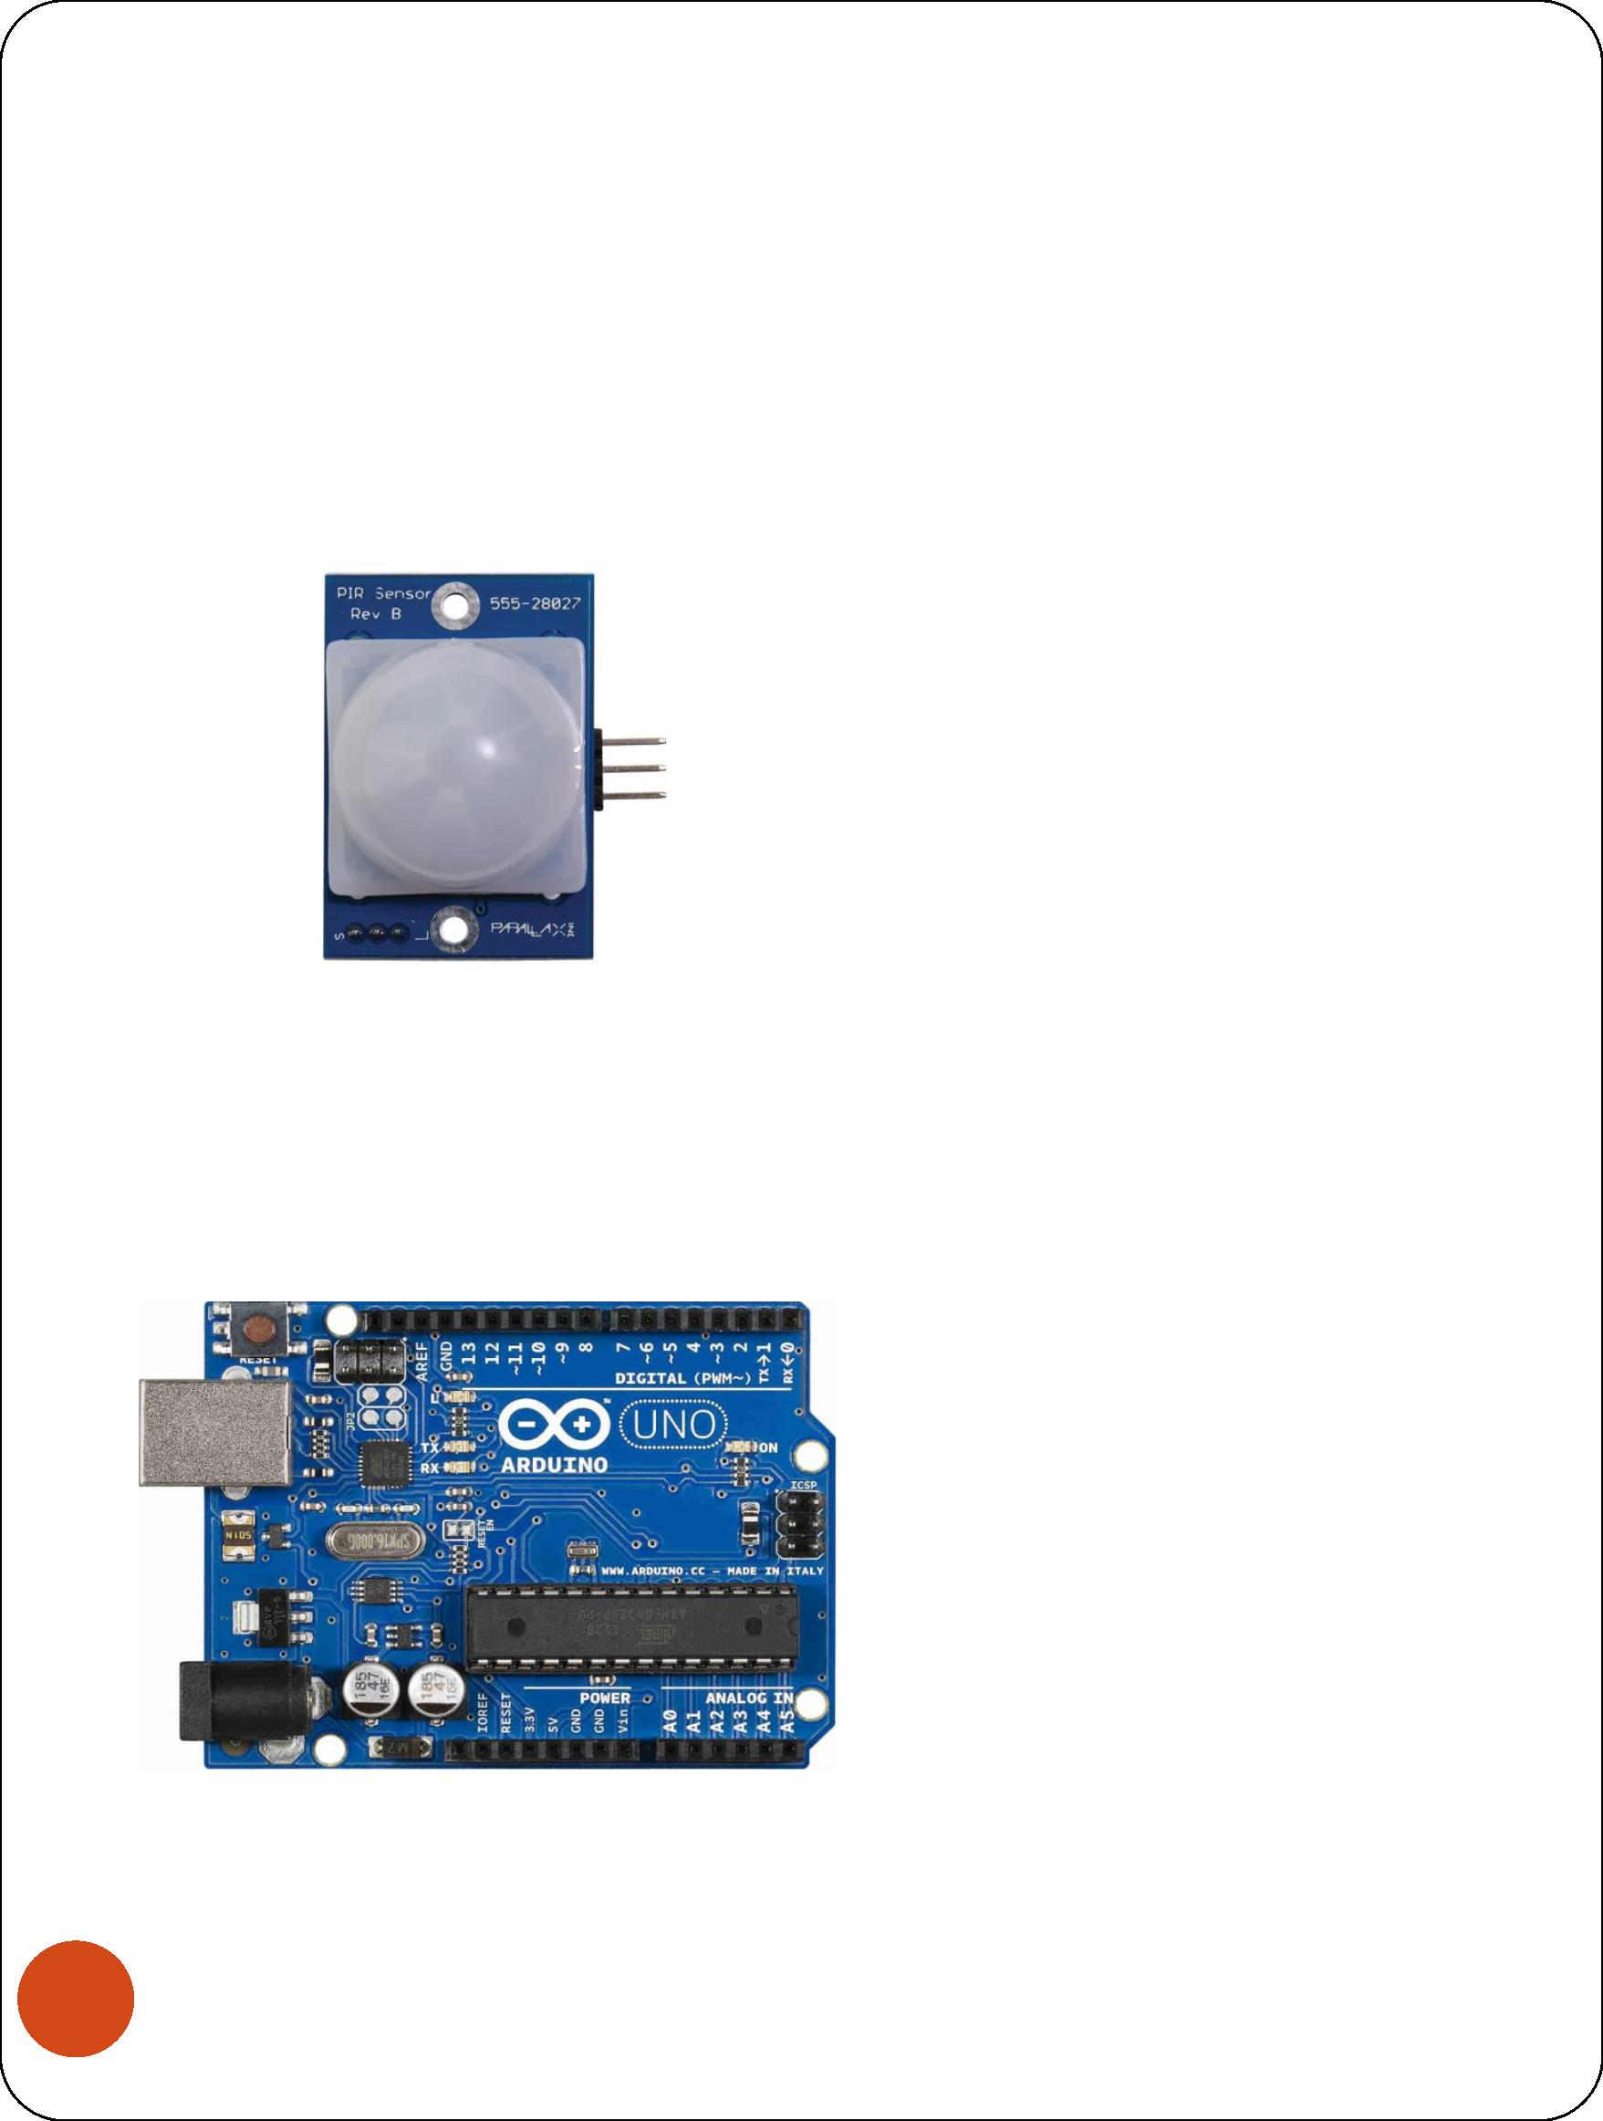

3) GSM SIM 900 module in which the SIM is fixed, makes a call

and alerts the owner

**APPLICATIONS:**

1) It is a small device and can be installed any where

2) It is a budget friendly device and every home can have it and

improve their security

3) Many external features can be added to it such as Camera,

microphone etc.

4

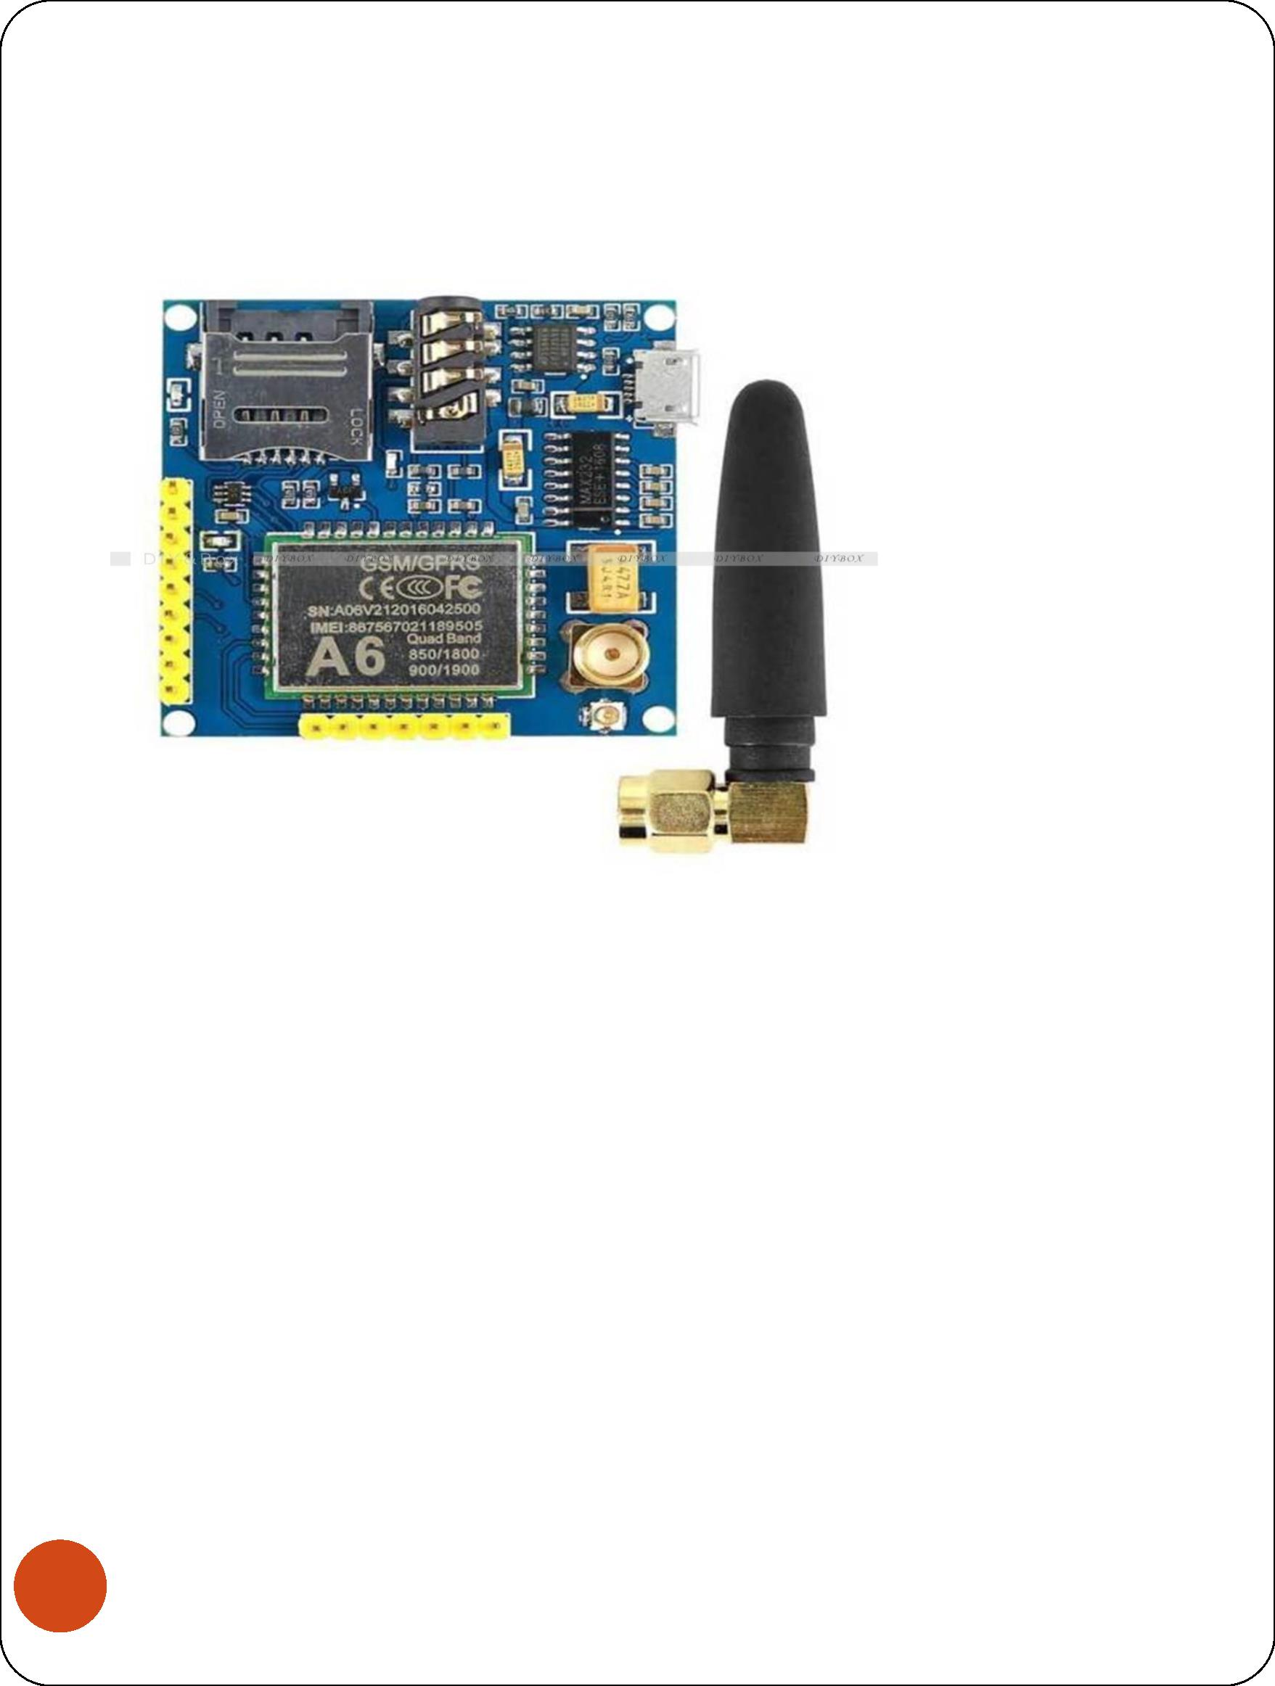

**CODE:**

#include <SoftwareSerial.h>

SoftwareSerial mySerial(9, 10);

int inputPin = 5;

int val = 0;

void setup() {

pinMode(inputPin, INPUT);

Serial.begin(9600);

}

void loop(){

val = digitalRead(inputPin);

if (val == HIGH) {

mySerial.begin(9600);

delay(2000);

mySerial.println("ATDxxxxxxxxxx;");

}

else {

}

delay(2000); }

5



6

